|  |
| --- |
| ATM |
| Report #1:Object Oriented Analysis |
| Submitted By:- 1  Name 1:student Id1  Name 2:student Id2  Name 3:student Id3  Name 4:student Id4  Name 5:student Id5 |

Submission Date:-

1

Report #1: Responsibility Matrix

|  |  |  |  |  |  |  |  |
| --- | --- | --- | --- | --- | --- | --- | --- |
| **Project title** | | **Team#Number** | | | | | |
| **Name1** | **Name2** | **Name3** | **Name4** | **Name5** | **Name 6** |
|
|
|
| **Task** | |
| 1.1 | Problem Statement |  |  |  |  |  |  |
| 1.2 | .Glossary of Terms |  |  |  |  |  |  |
| 2.1 | Functional Requirements | REQ 3  REQ 5 | REQ 7  REQ 1 | REQ1 REQ 3  REQ 5  REQ 2 |  |  |  |
| 2.2 | Nonfunctional Requirements | REQ 10  REQ 12 |  |  | REQ 7  REQ 6 | REQ 13  REQ 15 | REQ 1  REQ 5 |
| 3.1 | Stakeholders |  |  |  |  |  |  |
| 3..2 | Actors and Goals |  |  |  |  |  |  |
| 3.3.1 | Use Case Casual Description | Startup ATM  ShutDown Atm | Print Bill | Deposit | withdraw | Check Balance | Change PIN |
| 3.3.2 | Use Case Diagram | Startup ATM  ShutDown Atm | Print Bill | Deposit | withdraw | Check Balance | Change PIN |
| 3.3.3 | Trace-ability Matrix |  |  |  |  |  |  |
| 3.3.4 | Fully-Dressed Description | Startup ATM  ShutDown Atm | Print Bill | Deposit | withdraw | Check Balance | Change PIN |

**Ensure that the page numbers listed here are correct**

1. **Customer Statement of Requirements (CSR)**
   1. **Problem Statement**

The software ATM version1.0 is to be developed for Automated Teller Machines (ATM). An automated teller machine (ATM) is computerized telecommunications device that provides a financial institution's customers a secure method of performing financial transactions, in a public space without the need for a human bank teller. Through ATM, customers interact with a user-friendly interface that enables them to access their bank accounts and perform various transactions.

The network enables customers to complete simple bank account services via automatedteller machines (ATMs) that may be located off premise and that need not be owned andoperated by the customer’s bank. The ATM identifies a customer by a cash card and password. It collects information about a simple account transaction (e.g.,deposit, withdrawal,transfer, bill payment),communicates the transaction information to the customer’s bank,and dispenses cash to the customer. The banks provide their own software for their own computers

* 1. **Glossary of Terms**

|  |  |
| --- | --- |
| Term | Definitions |
| ATM | Automated teller machine |
| PIN | Personal Identification Number |
| Account | A single account at a bank against which transactions can be applied. Accounts may be ofvarious types with at least checking and savings. A customer can hold more than one account. |
| Smart Card | Card without hardware which stores the user’s private keys  within a tamper proof software guard. |
| SRS | Software Requirements Specification |
| Internet | An interconnected system of networks that connects computers around the world via the TCP/IP protocol. |

1. **System Requirements**
   1. **Enumerated Functional Requirements**

Extract the requirements from the customer’s narrative and list them in a table, one row per requirement. The first column shows a unique label “REQ-*x*”. The second column shows an assigned *Priority Weight* of this requirement. The third column briefly describes the requirement.

|  |  |
| --- | --- |
| IDENTIFIER | REQUIREMENT |
| REQ1 | A customer must be able to make a cash **withdrawal** from any suitable account linked to the card, in multiples of $20.00. Approval must be obtained from the bank before cash is dispensed. |
| REQ2 | A customer must be able to make a **deposit** to any account linked to the card. The customer will enter the amount of the deposit into the ATM. |
| REQ3 | A customer must be able to make a **transfer** of money between any two accounts linked to the card. |
| REQ4 | A customer must be able to make a **balance inquiry** of any account linked to the card. |
| REQ5 | A customer must be able to **abort a transaction** in progress by pressing the Cancel key instead of responding to a request from the machine. |
| REQ6 | The ATM will communicate each **transaction** to the bank and obtain **verification** that it was allowed by the bank. Ordinarily, a transaction will be considered complete by the bank once it has been approved. In the case of a deposit, a second message will be sent to the bank indicating that the customer has deposited the envelope. (If the customer fails to deposit the cash within the timeout period, or presses cancel instead, no second message will be sent to the bank and the deposit will not be credited to the customer.) |
| REQ7 | The ATM will provide the customer with a **printed receipt** for each successful transaction, showing the date, time, machine location, type of transaction, account(s), amount, and ending and available balance(s) of the affected account ("to" account for transfers). |
| REQ8 | The ATM will have a key-operated switch that will allow an operator to **start and stop** the servicing of customers. After turning the switch to the "on" position, the operator will be required to verify and enter the total cash on hand. The machine can only be turned off when it is not servicing a customer. When the switch is moved to the "off" position, the machine will shut down, so that the operator may remove deposit envelopes and reload the machine with cash, blank receipts, etc. |
| REQ9 | The ATM will also maintain an **internal log** of transactions to facilitate resolving ambiguities arising from a hardware failure in the middle of a transaction. Entries will be made in the log when the ATM is started up and shut down, for each message sent to the Bank (along with the response back, if one is expected), for the dispensing of cash, and for the receiving of an envelope. Log entries may contain card numbers and dollar amounts, but for security will never contain a PIN. |

* 1. **Enumerated Nonfunctional Requirements**

|  |  |
| --- | --- |
| IDENTIFIER | REQUIREMENT |
| NF-REQ1 | The ATM unit consists of a display, a card reader, a cash dispenser, an envelope drawer, an envelope slot, a keypad and a printer |
| NF-REQ2 | The keypad is a set of buttons that includes the following: 10 buttons labeled with numbers 0 to 9, an OKAY button, a CLEAR button, a CANCEL button, and dynamic buttons that perform different actions. |
| NF-REQ3 | A PIN must be entered within 20 seconds. |
| NF-REQ4 | The User must enter the PIN correctly within three attempts |
| NF-REQ5 | ATM suspends further access using a particular card if the associated PIN is entered incorrectly 3 times in succession. |
| NF-REQ6 | The ATM must be secure. |
| NF-REQ7 | The ATM can be shut down and restarted |
| NF-REQ8 | The cash dispenser can be opened and refilled with cash |
| NF-REQ9 | The printer can be opened and refilled with paper |

1. **Functional Requirements Specification**

Derive the use cases based on the requirements from Section 1 and Section 2 above.

* 1. **Stakeholders**

**User** : End user who retrieves money, do bank transfer, check balance

**Maintenance:** person from bank who ,charges the money, maintains printer (ink, paper),

gets retrieved cards

**Security auditor:** from credit card circuit (accepts or not the system to be connected with credit card circuit)

**Security administrator** : monitors security issues on ATM

**IT administrator:** installs patches of the application, maintains platform (updates to OS, ..)

**CEO: Top manager** of bank

**Developers and** Analysts : software development team member.

* 1. **Actors and Goals**

|  |  |  |  |
| --- | --- | --- | --- |
| Actor | Type | Actor’s Goal | Use Case Name(UC-#) |
| Customer |  | Perform Transaction Using ATM | Customer |
| Maintenance |  | Maintenance ATM | Operator |
| Bank |  | Accepts deposits from the customer and provide financial services | Bank |

* 1. **Use Cases**

Casual Description

**UC-1:** **Startup**— The system is started up when the operator turns the operator switch to the "on" position. The operator will be asked to enter the amount of money currently in the cash dispenser, and a connection to the bank will be established. Then the servicing of customers can begin. [Derived from REQ8]

**UC-2:** **Shutdown**— The system is shut down when the operator makes sure that no customer is using the machine, and then turns the operator switch to the "off" position. The connection to the bank will be shut down. Then the operator is free to remove deposited envelopes, replenish cash and paper, etc.[Derived from REQ8]

**UC-1:** **Session**—A session is started when a customer inserts an ATM card into the card reader slot of the machine. The ATM pulls the card into the machine and reads it.[Derived from REQ6]

**UC-1:** **Transaction**—[Derived from REQ8]

**UC-1: Startup**—[Derived from REQ8]

**UC-1: Startup**—[Derived from REQ8]

* + 1. Use Case Diagram  
       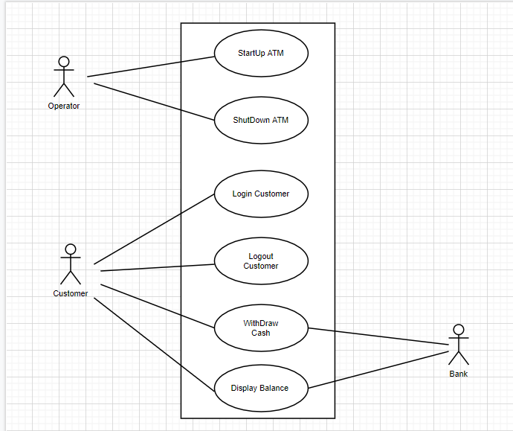
    2. Traceability Matrix  
       Show how your system requirements map to your use cases. Calculate the priority weights of your use cases

: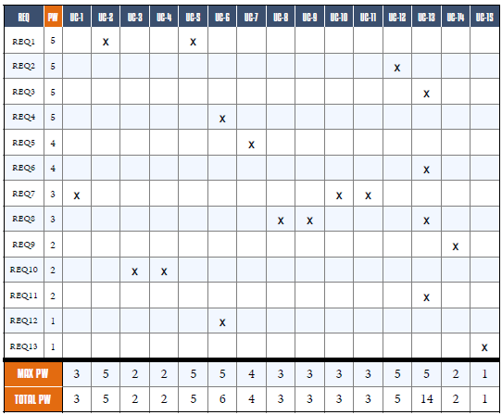

* + 1. Fully-Dressed Description  
       Select a **few most important** use cases and provide *detailed* (“fully dressed”) description. The “most important” use cases are indicated by your traceability matrix.  
       Your event flows must show step-by-step *every action that the initiating actor (“user”) can take* while running the given use case.

Example :-

|  |  |
| --- | --- |
| **Use Case UC-1:** Register | |
| Related Requirements: |  |
| Initiating Actor: |  |
| Actor’s Goal: |  |
| Participating Actors: |  |
| Preconditions: |  |
| Post conditions: |  |
| **Flow of Events for Main Success Scenario:** | |

|  |  |
| --- | --- |
| **Use Case UC-1:** Register | |
| Related Requirements: |  |
| Initiating Actor: |  |
| Actor’s Goal: |  |
| Participating Actors: |  |
| Preconditions: |  |
| Post conditions: |  |
| **Flow of Events for Main Success Scenario:** | |
| **Use Case UC-1:** Register | |
| Related Requirements: |  |
| Initiating Actor: |  |
| Actor’s Goal: |  |
| Participating Actors: |  |
| Preconditions: |  |
| Post conditions: |  |
| **Flow of Events for Main Success Scenario:** | |
| **Use Case UC-1:** Register | |
| Related Requirements: |  |
| Initiating Actor: |  |
| Actor’s Goal: |  |
| Participating Actors: |  |
| Preconditions: |  |
| Post conditions: |  |
| **Flow of Events for Main Success Scenario:** | |
| **Use Case UC-1:** Register | |
| Related Requirements: |  |
| Initiating Actor: |  |
| Actor’s Goal: |  |
| Participating Actors: |  |
| Preconditions: |  |
| Post conditions: |  |
| **Flow of Events for Main Success Scenario:** | |
| **Use Case UC-1:** Register | |
| Related Requirements: |  |
| Initiating Actor: |  |
| Actor’s Goal: |  |
| Participating Actors: |  |
| Preconditions: |  |
| Post conditions: |  |
| **Flow of Events for Main Success Scenario:** | |

* 1. **System Sequence Diagrams**

Draw the system sequence diagrams for the **all**  use cases selected above.

1. **User Interface Specification**

(Note: If your system prints some forms or generates periodic reports, this is also considered part of the user interface and the format of forms/reports must be specified in this section.)  
The user interface should be specified only for the use cases elaborated in the previous section (“fully dressed” use cases).

* 1. **Preliminary Design**

For a given use case, show step-by-step how the user enters information and how the results appear on the screen.  
Use *screen [mock-ups](http://en.wikipedia.org/wiki/Mockup)* and describe exactly what fields the user enters and buttons the user presses. Describe *navigational paths* that the user will follow.   
In case you are developing a graphics-heavy application, such as a video game, this is one of the most important sections of your report.

* 1. **User Effort Estimation**

Select several typical usage scenarios and, as you walk through the flow of events, count and report the number of mouse clicks and/or keystrokes that are needed to accomplish the task. What fraction of these goes to user-interface navigation vs. clerical data entry?

1. **Domain Analysis**
   1. **Domain Model**

Show the process of deriving the domain model and then draw the diagram. Provide text description of:

* + 1. Concept definitions
    2. Association definitions
    3. Attribute definitions
    4. Traceability matrix — show how your use cases map to your domain concepts.
  1. **System Operation Contracts**

Should be provided only for the operations of the fully-dressed use cases elaborated in Section 3.c), for their system operations identified in Section 3.d).

* 1. **Mathematical Model**

Do you use any mathematical models? E.g., you may use a statistical model for stock price prediction, or a geometric model for computing the trajectories for animate figures in a video game. 

If NO, skip to the next item;   
If YES, describe precisely your model.

1. **Plan of Work**

Describe what your group is planning to do after submitting report#1 until the end of the semester. Show the roadmap with projected milestones and dates by which you plan to accomplish them. Of course, your plans for the short term (next few weeks) should be much more detailed than further in the future.  
Preferably, you should use [Gantt charts](http://www.ganttchart.com/) for planning and scheduling your project. Also provide the breakdown of responsibilities: what each team member did so far, is currently doing, will do in the future, including management and coordination activities.